- The core principles of Object-Oriented Programming.
Object-Oriented Programming (OOP) is a programming model focusing around ‘objects’ rather than just logic and functions. OOP makes code more flexible, easier to maintain, and more modular.

- Application Development:
  - OOP Principles Application
During creating a simple library management system I used four main pillars of Object-Oriented Programming to make code modular and easy to be maintaining.
    - Abstraction and class modelling:
A base class – Product define common features (title, price) without repeat repetition.
    - Encapsulation:
Sensitive data (price, pages) has been protected against uncontrolled modification. By using setter (setPrice), system prevents setting a negative price.
    - Inheritance:
Instead, creating independent classes for each resource I used relation “is-a”. That’s why Book and Ebook automatically take over functionality of the parent class.
    - Polymorphism:
I used dynamic polymorphism by method overriding. Thanks that the system can handle list of objects (books and e-books) in one loop, calling the same method (getInfo()), which automatically adjust result to specific object type.
    - Object Composition:
Instead treat an author as normal text, I used Author class. Including an author object in the Book class allows for better management of related data and ownership consideration (has-a).

  - Classes and Objects
In this section, I define the core classes of the Library System. Each class act as a blueprint, defining specific attributes and methods to manage the library.

The core class for all items is a Product class. It serves as a Parent Class that establishes the common properties for any item avaible in the lbrary. Also, this class implements encapsulation to protect data integrity.

This class contains:
- Attributes:
  - $title (protected string) – the name of the product.
  - $price (protected float) – the cost of the product.
- Methods:
  - __construct (string $title, float $price) – This is the method that runs when a new product is created. It maps the incoming parameters to the class properties and ensure starts with valid data by calling the setPrice() method.
  - setPrice(float $price) – a setter method that validates if the price is not a negative number before saving it.
  - getInfo(); returns a basic string representation of the product.
Snippet 1 - Product class
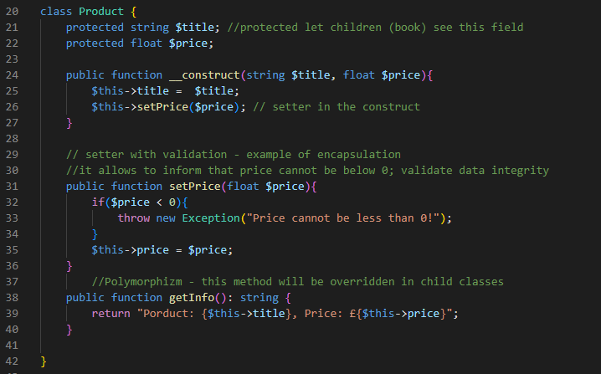

The Book class is one of the primary classes in the application. It inherits (extends) from the Product class. This means it automatically gets the title and price logic from the parent, so it didn’t to write it again.
This class contains:
- Attributes:
  - $author (public Author) - an instance of the Author class (this is called Composition)
  - $pages (private int) – the total number of pages (hidden from outside access).
  - $year (public int) – the publication year.
- Methods:
  - __construct() – calls the parent constructor and initializes book (specific) data.
  - getInfo() – overrides the parent method to return a detailed HTML list of book properties.

Snippet 3 - Book class (extends Product)
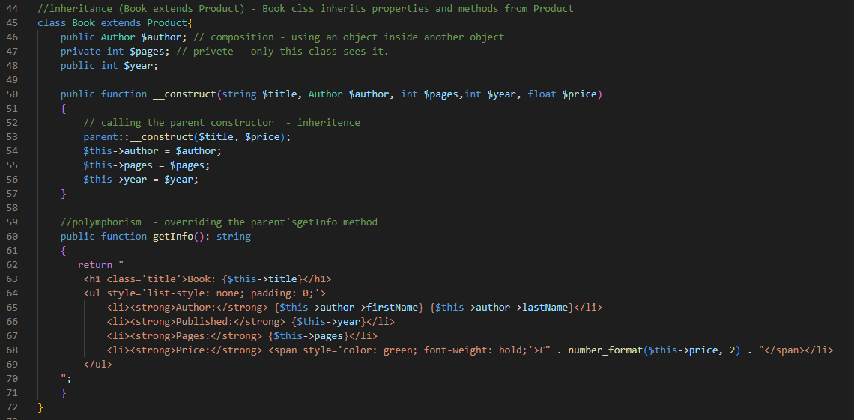

The last one of the main classes is Library class. This class doesn’t represent a thing like a book; it represents the system that holds everything together.
This class contains:
- Attributes:
  - $bookItems – A privet list array where all my book and E-boo object are stored.
- Methods:
  - addBookItem() – This method lets me add a new book to the list. I told it to accept any Product, so it can handle both: normal books and E-books.
  - showAllCatalog() – This is simple loop which goes through the list and tells every book to show its info (getInfo()) on the screen.

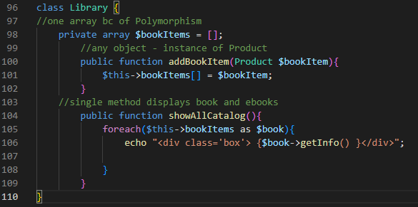

  - In my application, I used inheritance to create a specialized version of a book without rewriting all the code. I think, the best example is the Ebook class, which Inherits from the Book class.
In my code, by using key word extends, the Ebook class automatically gets everything the Book class has (like title, author, and the price).
It useful because I didn’t have to create new fields for title or author inside the class.
In the constructor I used parent::__construct(). This is a huge time sever because it uses logic I already wrote in the Book class.
It allows me to keep physical books and e-books separate.

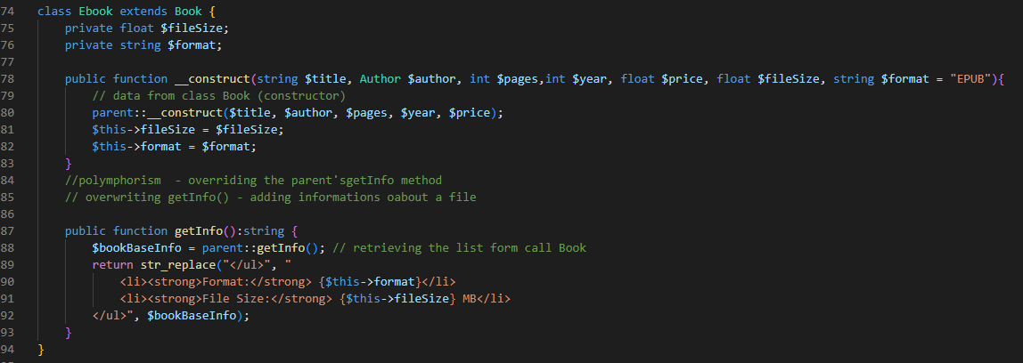

  - Encapsulation is about to hiding the internal data of the object and allowing it to be changed through specific, safe methods. This prevents bugs and ensure that the data in my application is always valid.
In my code, I didn’t use every single variable as public. For example, in Product class, I used protected for the price, and in the Book class, I used private for pages.
This means that a programmer cannot just type $book->price = -50; form outside the class.
The best example in my system is the setPrice method. It provides a public way to modify private data, but it includes validation check.
Why this is important?
By encapsulating the $price, I make sure the library never accidentally has a book that costs less than zero. If I ever want to change how the price is calculated, e.g. adding tax, I anly have to change it in one place instead of searching through out my whole project.
Using private for $pages in the Book class ensures that this information is only handled by the book itself. It make the code clean and organized.

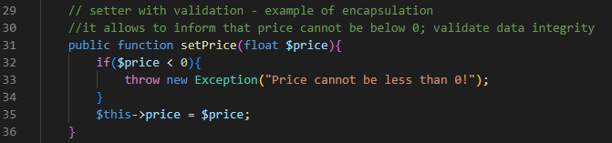

  - Polymorphism is one of the most powerful features of Object-Oriented Programming. It allows different classes to be treated as instance of the same parent class.

The core polymorphism in my project is th getInfo() method. It is first defined in the Product class to show a basic title and price, then it is overridden in the Book class to include the author and year/ Finally, it is overridden again in Ebook class to add digital details like file size and format.
The real benefit of polymorphism is visible in my index.php and Library class. I can store mix of different objects (Books and Ebook) in collection and display them using a single, simple loop. The system knows which version of getInfo() to call based on the object type.
If I want to add “Audiobooks” to the system later, I only need to create a new class with own getInfo() method. I will not have to change any code in the Library class or the index.php file.

